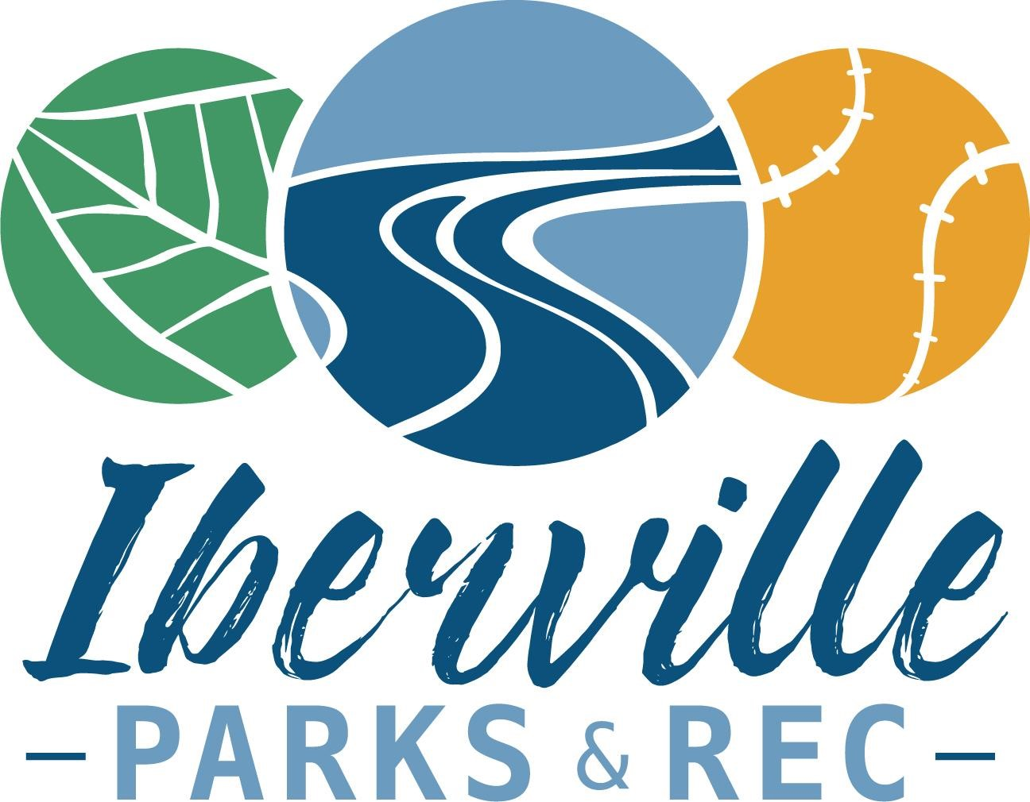
IPRD Post Rec League Policy/Guidelines
- It is the mission of Iberville Parks and Recreation Department to create opportunities for our residents to enjoy safe, welcoming recreational facilities and affordable, diverse recreational opportunities for people of all ages to play and learn.
- It is with this in mind that we are shifting our focus towards learning and having fun for our younger parish residents while they compete in our recreational programs.
- IPRD will no longer select “All-Stars” from its sports leagues. However, if any coach wants to form a more competitive team to play tournament ball, IPRD will provide (limited) financial support, equipment and uniforms for these teams as long as the teams are made up of 100% of kids that have registered and played in our league during the most recent season.
- It is the responsibility of the person forming the team to select players and manage rosters. A player can only be on one roster at a time. All rosters must be approved by IPRD.
- The number of teams will be based upon the number of registrations received, volunteer coaches, and the general level of interest among our parents and players. For more details, contact the IPRD office.

